Week 9-10 Exercise

Jon K. Jacobson
Bellevue University
DSC640 T301 2257: Data Presentation and Visualization
Dr. Ben Schneider
August 10, 2025

Audience
For this assignment I put myself in the shoes of an airline analyst that is evaluating complaints on behalf of the company. I didn’t have per-airline data, but I am confident the same kind of analysis could be done given the ability to filter the complaints by airline. The idea would be to give recommendations to company leadership on how to improve business operations.
Purpose
The purpose of this would be to improve airline business operations. The questions I’m trying to answer are the kinds of complaints, what is driving them, and what can be done to mitigate them. The benefit of having the published data (as well as the proprietary data from the company I would be working for) is that it gives us a baseline and allows us to seek areas where we can get competitive advantage. Specific recommendations from this analysis would include:
- Consistent, round-the-year intervention is necessary. There is no significant pattern of intensity by time of year.
- The number of complaints correlates across categories, indicating that systematic intervention is required.
- There is significant opportunity to gain competitive advantage, especially in specific states and airports. Targeting these areas for improvement would have the greatest impact.
Medium
Given the audience, the medium would probably be a presentation. We’d want to start with the larger context, focus on specific complaint categories next, and finally drive the conclusion home with specific recommendations.
Design
I chose to apply the techniques we’ve been learning to minimize noise and clutter in the visualizations so that the data stands out clearer. I tailored the types of visualization to the kinds of stories I wanted to tell with the data. I chose the type of visualization not match the story, such as choosing a top-ten visualization not highlight the most impactful complaint categories.
Ethical Considerations
Some of the complaint categories were highly sensitive. Issues like civil rights, or pat down complaints, are highly personal and sensitive. The data has been anonymized and aggregated so that identifying individuals is not possible, but these were critical steps to maintain an ethical approach to publishing this data. In general, any type of complaint could be perceived as a private matter and concern should be taken to ensure there is consent from both parties to publish that data in an individually specific way. Published reviews would be a situation where consent is implied, but a private complaint to a company would be something that would require specific consent to publish.

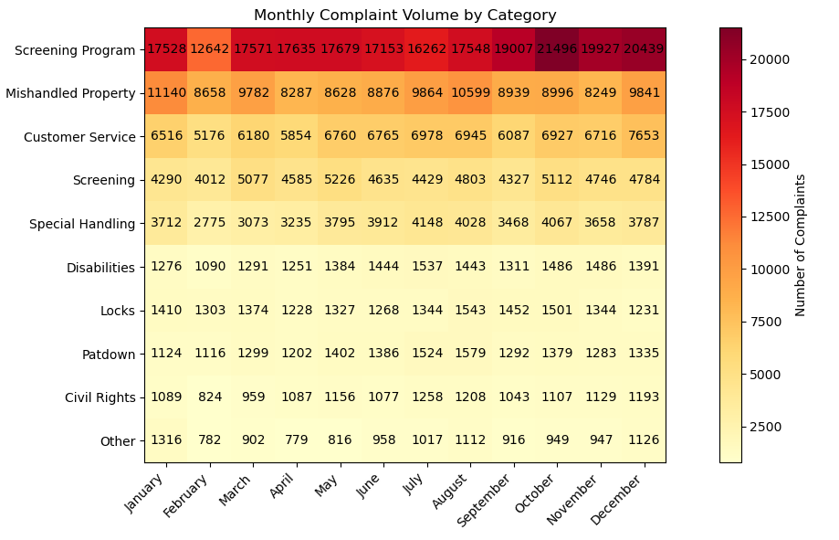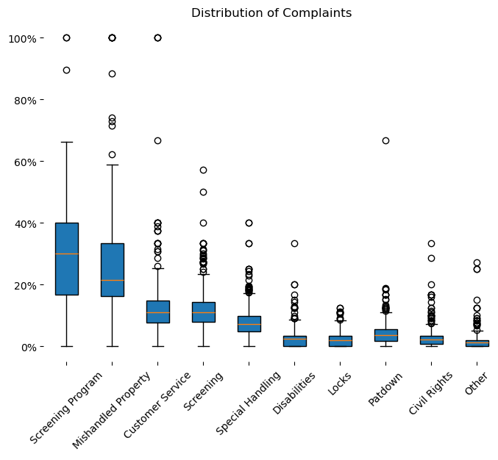
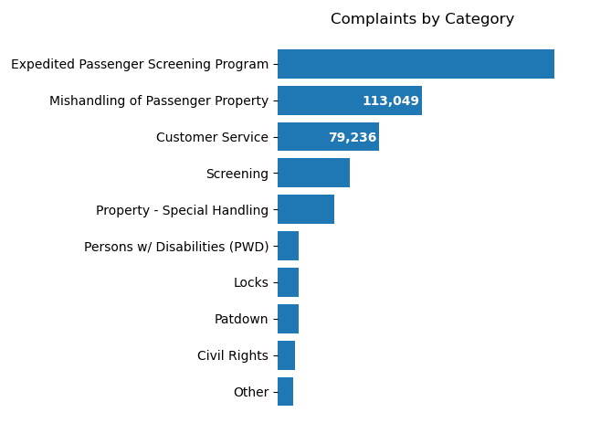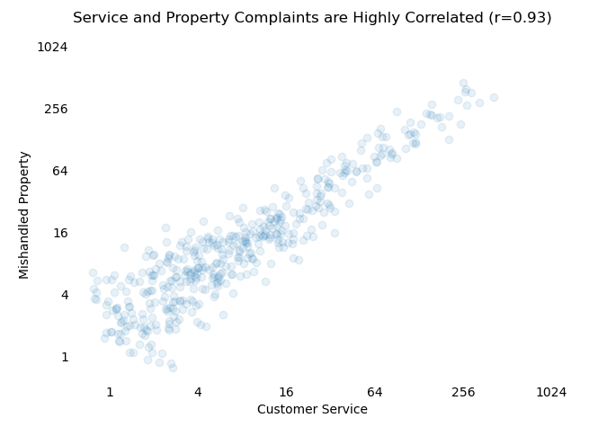

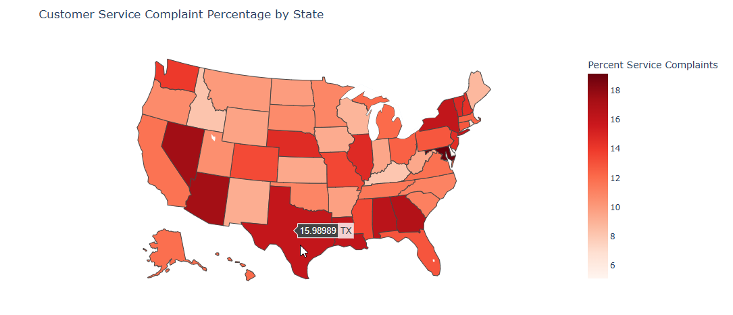

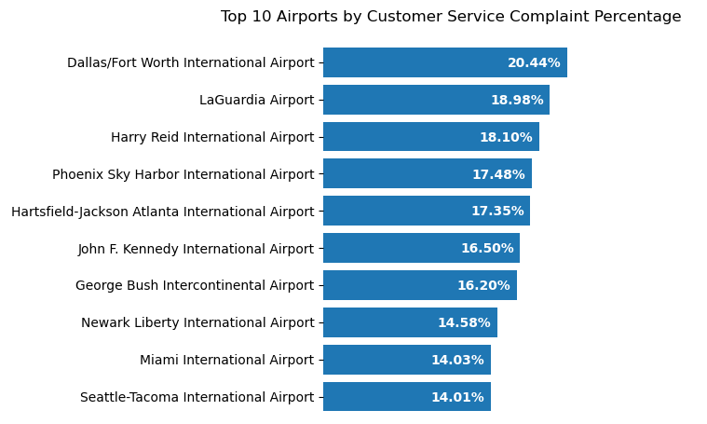

References
Data Liberation Project. (n.d.). TSA complaint counts [Data set]. Retrieved August 3,2025 from GitHub. https://github.com/data-liberation-project/tsa-complaint-counts/tree/mainState.
New IP2Location. (n.d.). iata-icao.csv [Dataset]. GitHub. https://github.com/ip2location/ip2location-iata-icao/blob/master/iata-icao.csv.

